How do consumers appreciate boars, barrows and immunocastrates?
Are you willing to perform a consumer trial to evaluate the sensory appreciation of meat from boars, barrows and immunocastrates and consumer attitudes on these alternatives? Timing is January/February 2019.

Context
SUSI is a European project that wants to evaluate the sustainability in pork production with immunocastration. Consumers acceptance of immunocastration and sensory appreciation of the meat are important elements in this evaluation. We would like to perform this study in as many countries as possible (10 maximum) and would really appreciate your help. Costs can not be refunded, but all material will be delivered free of charge and in each country, 1 author can be included to the final A1 publication.

Samples
- Loin samples of 30 boars, 30 barrows and 30 immunocastrates are collected in trial performed in Belgium.
- Samples and test material will be shipped to you, free of charge.

Sample preparation
- Grill 2000W (for example Tefal GC3060 for which extra plates can be ordered)
- To internal temperature of 72°C, samples should be prepared and served immediately
- A standardized protocol for sample preparation will be provided.

Experimental set-up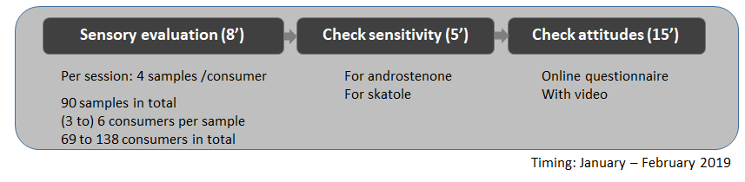
Step 1: sensory test
- Each sample should be divided and evaluated by at least 3 and preferably 6 consumers.
- Each consumer evaluates 4 samples according to a balanced design which will be provided by us.
- This results in 23 sessions in total, with at least 69, but preferably 138 consumers in total
- All questionnaires will be provided in English.
Step 2: Sensitivity test
- Test strips: A standardized protocol and score card for checking sensitivity will be provided, free of charge
Step 3: Attitude check
- Video will be provided in English
- Online (or paper) questionnaire will be provided

Are you willing to participate? | Yes / Possibly / No
Are you able to perform this trial in January/February 2019?  If not, when are you able to perform the trial? | Yes / No
Do you have sensory boots? | Yes / No
If yes, please indicate the number of boots
If not, are you able to standardize the conditions as much as possible?
How many consumers can you include per session?
Are you able to perform 23 sessions in total? | Yes / No
Are you able to include a representive group of consumers  - age 18 to 65, distributed according to demographics  - sex 50/50  - rural/urban background  If not, please specify | Yes / No
Can you perform the sensory study digital or on paper? | Digital / on paper
Can you perform the attitude questionnaire on a computer  (online questionnaire will be available) | Digital online  Digital not online  On paper
If not, is there a possibility to show the video for the attitude questionnaire (without further interference) | Yes / No
Are you able to send the results by the end of March 2019? | Yes / No
Contact details
- Email
- Phone number
- Skype

